Dear sister/brother in Christ,

If you have a large family, your refrigerator is full of pictures. On the back are more members of your family: four infants and one adult baptized at St. Paul’s in one weekend in July! Their smiles are thank-you’s for your generous support of gospel ministry.

A Response of Thanksgiving

When the Safer-at-Home order was enacted, we prepared for a significant reduction in offerings. Instead, the offerings in the fiscal year that ended June 30th were 3% above plan. Seeing this generous response of God’s people, the Ministry Board approved offerings of thanksgiving: $11,850 to synod missions and $5,630 to Wisconsin Lutheran High School. These amounts are 5% above our annual commitments to these ministries. Many are giving thanks to God for your generosity!

More Good News

For nearly 20 years, we borrowed money from dedicated funds for operating expenses. About 10 years ago, that internal debt had grown to $265,000. We are happy to report that the internal debt has been erased! Our only outstanding debt is the $1.4 million mortgage on our 2010 school addition. Gifts in the green “Picnic Offering” envelop will go towards reducing our mortgage or give online at StPaulMuskego.org/Give.

Outdoor Service

Bring your lawn chairs and join us for our annual outdoor worship this Sunday, August 2 at 10:30 am under the trees behind the Trinity Gym. While we won’t be providing picnic food, we encourage you to bring your own picnic lunch and spend some time after the service enjoying our beautiful campus and time with friends. It will be wonderful to see many of our St. Paul’s family for in-person worship.

We will still have our Saturday 5 pm, Sunday 7:45 am and Wednesday 7 pm services the week of August 2. We will not be able to livestream the outdoor service, but we will have the Traditional service recorded and available for our online worshipers by Saturday evening, August 1st.

One Weekly Mask-Required Service Beginning August 9

Beginning August 9th, we are designating the Sunday 10:45 am service “mask-required” for the adults who are present. For some this is an inconvenience; for others it is a health necessity. These on-going experiments in response to the pandemic are part of St. Paul’s living our mission: “By every possible means we bring every person within our area of influence closer to Christ.” Thank you for your patience and for your loving care for all your fellow St. Paul’s family members.

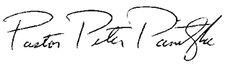
Christ’s servant,

Pastor Pete Panitzke
For the Ministerial Team

Family Pictures for Your Refrigerator!
Adeline, Madison, Everly, Jayce and Daniel
were all baptized at St. Paul’s the weekend of July 19!
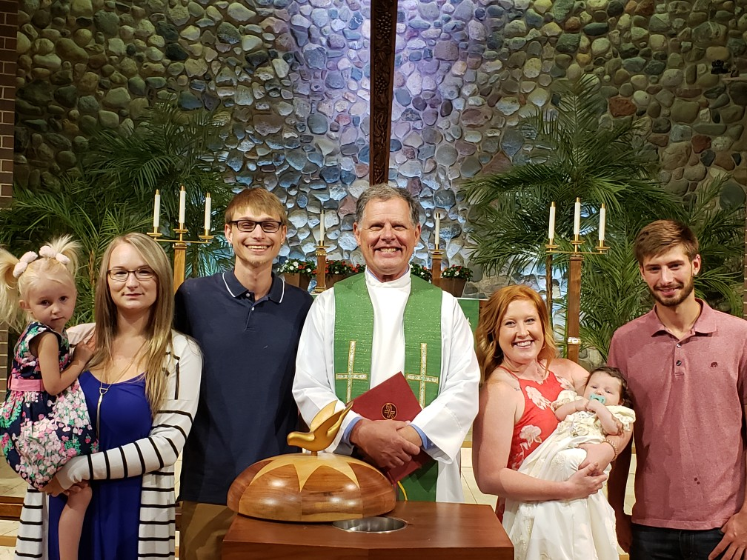
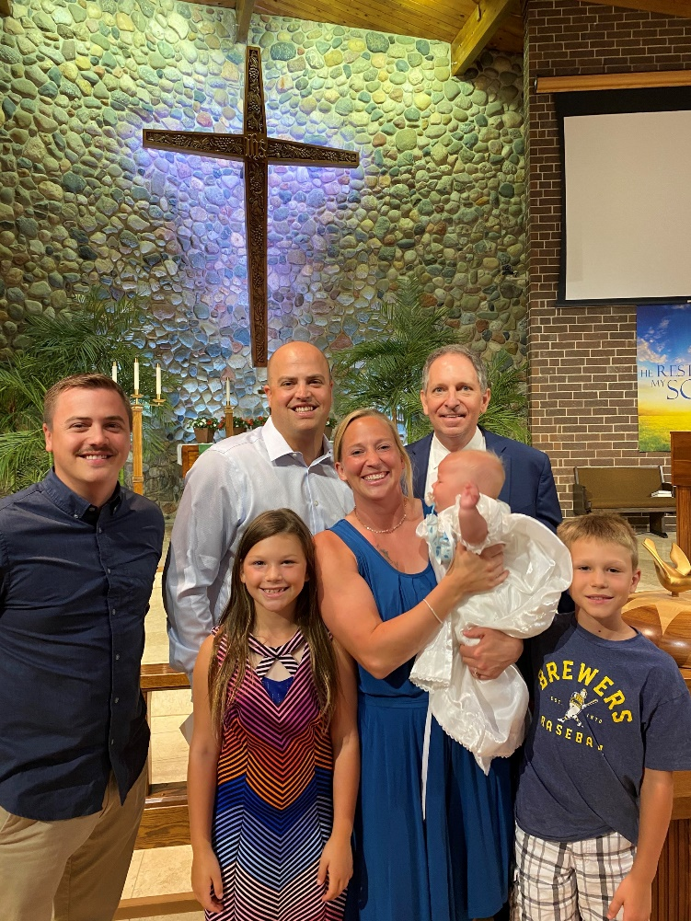

Thank you for your generous gifts that make these miracles of faith happen!

