FAMILY CHURCH

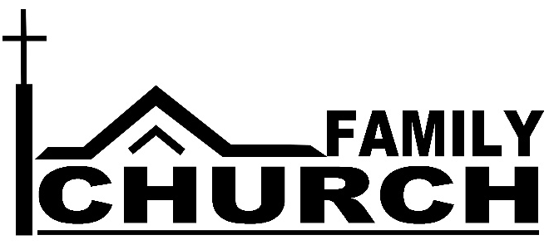
See a Family Church in Action
When Jesus came to Bethany, a family opened their home for a Life Group with Jesus at the center.
Mary and Martha didn’t always get it right. Mary sat at Jesus’ feet. Martha got angry with Mary and with Jesus. “Lord, don’t you care that my sister has left me to do the work?”
But even in this imperfect family, Martha’s faith grew. When their brother died, it was Martha who confessed about Lazarus, “I know that he will rise again in the resurrection at the last day.” About Jesus she confessed, “I believe that you are the Messiah, the Son of God, who is to come into the world.” It was Martha that showed love to her sister by calling her aside with the good news, “The Teacher is here, and is asking for you” (John 11:24,27,28).
Busy Martha and quiet Mary both found time to sit at Jesus’ feet. They learned of his love for them. They learned to love each other. That’s what happens in a Family Church.
Our Call to Lead Family Churches
If you are a parent, the Savior is calling you to lead your Family Church. “Train a child in the way he should go” (Proverbs 22:6). It is from mothers and fathers that children best learn of the Savior’s love and what it means to love each other.
This fall we will study Paul’s letter to the Ephesians with the goal of helping parents recognize themselves as their children’s first pastors called to lead the children to sit at Jesus’ feet. We are developing tools to help you fulfill your calling.
Our Call to Develop Family Churches
Even though we live in an urban area and may be connected with hundreds through social media, we can feel incredibly isolated. Loneliness is a plague that affects many of us.
“God sets the lonely in families” (Psalm 68:6). Trusting in this promise, we want to develop Family Churches, small groups from three to a dozen or more, a family of brothers and sisters in Christ who meet regularly to sit at Jesus feet together.
GroupLink
We are offering GroupLink twice (Thursday, September 13 and/or Sunday, September 16 at 6:30 pm) to link together brothers and sisters in Christ who would like to join in a Life Group.
GroupLink is a 90 minute experience in which those interested in small group Bible study get to know one another. As you mingle and discuss questions, you have a chance to learn where people live, whether they are married or single, with children or not, and what times they could meet as a group. At the end of the evening, you will actually have your first short Life Group meeting and schedule the next time this new Family Church will meet. After you meet several times, you will have the opportunity to decide if this group fits your needs or if you would like to join another Family Church.

