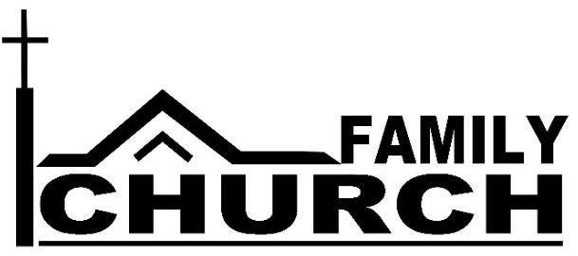
Watch Your Life and Doctrine
“Watch your life and doctrine closely. Persevere in them, because if you do, you will save both yourself and your hearers” (1 Timothy 4:16). The Apostle Paul wrote these words to a young pastor named Timothy.
These words apply to moms and dads too. When God blesses that a Christian husband and wife with children, moms and dads are called to pastor their children, to “watch your life and doctrine closely” to save yourselves and your children.
During the months of September and October as part of the Family Church series, we will help moms and dads fulfill their roles.
- We will admit our failures together.
- We will celebrate God’s forgiveness in Christ together.
- We will encourage each other to full our roles as “pastors to our family.”
Start Life Groups – New Family Churches
Most of us do not have children in our homes. Might this be a time for you to hear the call to be a “pastor” to your brothers and sisters in Christ. A pastor…
- Spends time with the people of his family to get to know them.
- Loves the people in his family and look for ways to help and encourage them.
- Prays for the people in his family because he knows their needs.
- Discusses God’s Word with the people in his family as they experience the various challenges of life.
This is what happens in Life Groups. Each member of the group serves as a pastor to the others so that no one faces the challenges of life alone.
GroupLink – Thursday, September 13 and/or Sunday, September 16 at 6:30 pm
New Life Groups will be formed at the GroupLink sessions. Use the Connection Card to let us know which GroupLink you will be able to attend.
Family Church – An Overview
Here is a quick overview of what will happen each week of the Family Church:
- September 9 – The message series begins, acknowledging that no family is perfect.
- September 16 – GroupLink will help individuals connect to a Family Church.
- September 23 – Small Groups will begin to meet.
- October 14 – RAWKs Fund. Families and small groups will be invited to receive a gift to which they can also contribute to be used for RAWKs – Random Acts of Worship Kindness.
- October 21 – Rededication – “Pastors” of families and groups rededicate themselves to fulfilling their roles so that they might “save yourself and your hearers” (1 Timothy 4:16).
- October 28 – Celebration – Remembering the ultimate goal of the Family Church, that we might celebrate together before God’s throne forever.

