Cool Progress!
It has been exciting to see some of the changes that have taken place on campus this summer, largely as a result of A Cool Million Capital Campaign. Because of the immediate outpouring of gifts (approximately $265,000) and additional plans for gifts ($400,000), we were able to do the following this summer!
Playground Parking Lot
You can see in this drone shot of our campus that the playground behind the school was repaved this summer.
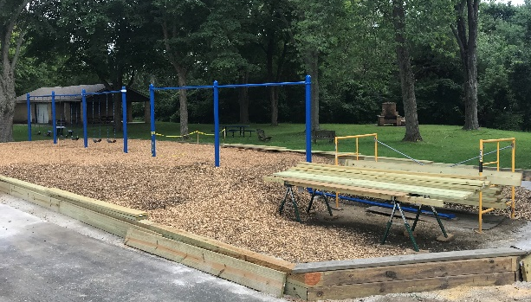
Playground Improvements
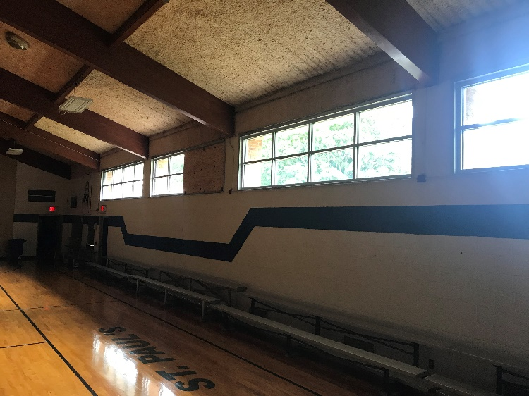
We are also adding another bay of swings on our playground!

Centennial Gym Windows
This completes a multi-year project to replace all the windows in the 1958 Youth Center portion of our school. The primary motivation was to improve energy efficiency, but we love the improved look as well!
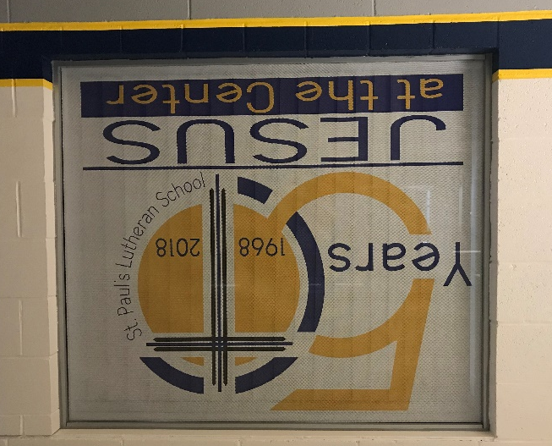
Window Decals and Painting
What are we celebrating with the 50th Anniversary of our school? Fifty years of having Jesus at the center of everything we do. This window decal in our school will remind our children of this truth all year long.
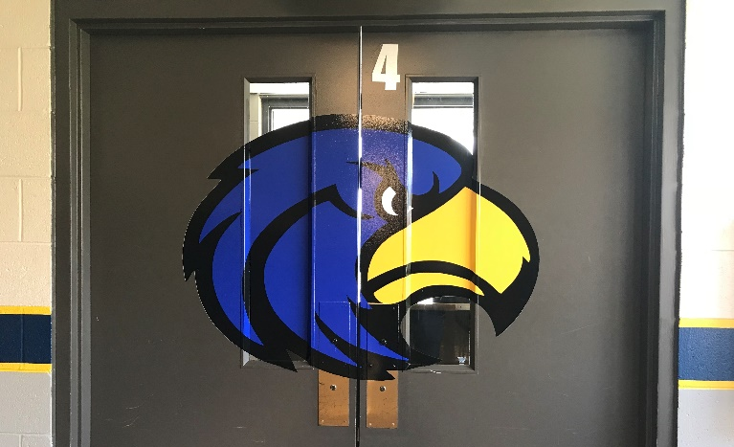
Children will also see new color in our hallways and our sport logo on the doors as they go out to the bus.
Our thanks to all those who gave so many hours of their time this summer to paint the hallways!
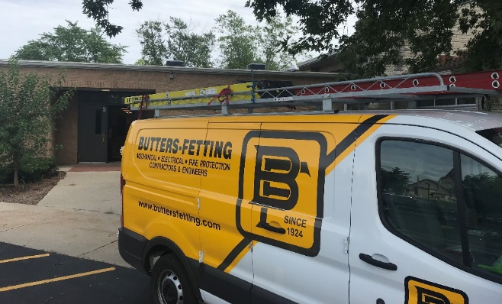
Almost Cool!
The HVAC work has just begun. Four classrooms and the Centennial Gym will have new furnaces and air conditioning installed this fall. The remainder of the HVAC work will be completed next summer.
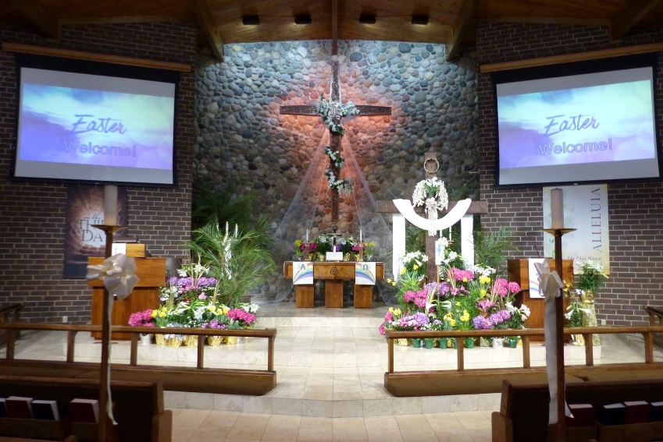

Sanctuary Improvements
In addition to these summer improvements in our school, we are already benefitting from new lighting in the sanctuary as a result of A Cool Million.
For all of these ministry improvements, we give thanks to God and to you, as God’s generous people!
Our Tithe
The first portion of our tithe (10%) of A Cool Million is going to Costa Maya Ministries on the Yucatan Peninsula in Mexico. At left you can see St. Paul’s member Dan Thiel driving some of the children to the ministry site in their old van that was constantly breaking down because of age and the rough road.
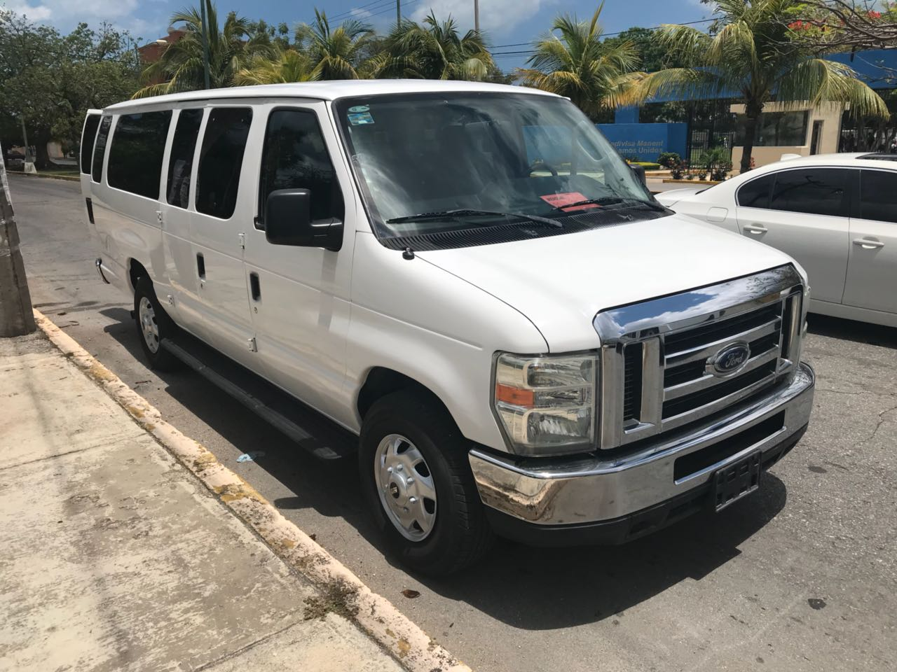
Our gift of $7000 was matched by another congregation to purchase this “new” 2011 van. Each week this van makes countless trips up and down the beach to pick up children for Bible studies and entire families for church services. A “new” van was essential to the ministry there.
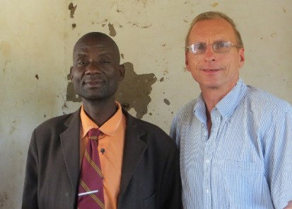
The remainder of our gift to Costa Maya Ministries ($23,000) will be used to help them purchase a permanent worship site.
Other tithe recipients will be the Malawi Mission field where our Mission Partner John Holtz serves and Garden Homes Lutheran Church and School on Milwaukee’s north side.

The final portion of our Cool Million tithe will provide $50,000 to send up to eight college graduates to places like Shanghai for a year to teach English as a Second Language, providing them with a chance to share the gospel through these contacts.
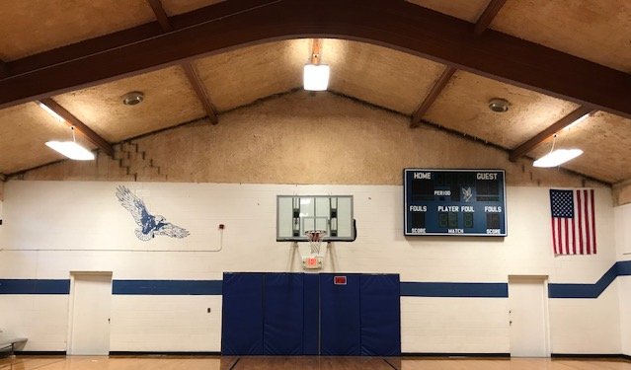
What’s Next?
Next summer we hope to complete not only the HVAC work in the school, but also the remodeling of the Centennial Gym with new roof, new ceiling treatment, and improvements to the electrical, sound and lighting systems for our school productions and our weekly Kids Club activities.
We will be developing these plans this fall. Completion depends on the continued contributions to A Cool Million. We will need to receive another $250,000 in gifts by February, 2019 to approve this work for summer of 2019.
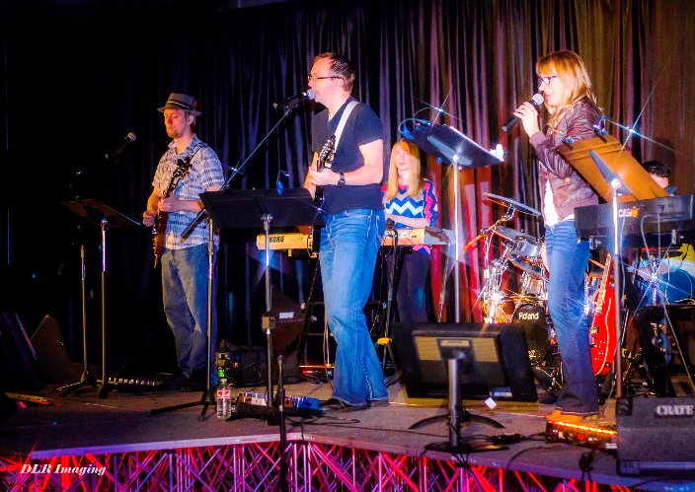
Future Projects
In 2020, as A Cool Million offering is completed, we hope to install permanent lighting and sound equipment in the Trinity Gym for The Bridge and other events. Other projects, if funds allow, include a new roof for the sanctuary and replacing the aging HVAC system in the sanctuary.

Support A Cool Million
Thank you if you have already been able to participate in A Cool Million. Thank you also for joining with us in prayer that this effort would be a blessing to our congregation.
An offering envelope for A Cool Million is attached. Gifts of every size are needed and appreciated… $25, $50, $100, $500, $1000 or more. Automated giving from a checking or savings account is the most cost-effective way for St. Paul’s to receive your gift. Go to www.stpaulmuskego.org/give.
If you would like assistance making a gift of appreciated stock or other tax-wise giving, contact our Church Administrator Randy Fink at 414-422-0320 ext. 120 for assistance.
Thanks a million for your generous support of gospel ministry!

