FAMILY CHURCH

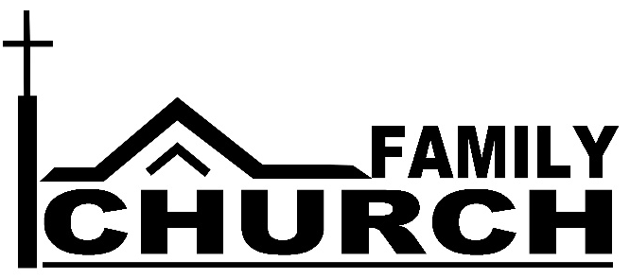
The Foundation Stone
“On this rock I will build my church.”
Peter had just confessed about Jesus, “You are the Christ, the Son of the living God.”
That truth is the foundation stone of the Church.
The Next Stone
But what is the next stone Jesus uses to build his church?
It is a stone that Satan is trying to pull out of God’s Church. Satan can pull it out because
- we don’t have time for it,
- we don’t feel qualified to lead it,
- we don’t feel connected to it.
The Importance of Family
The Family is the next stone Jesus lays upon the foundation. The family is where faith is most often and most thoroughly passed on. God instructed family leaders, “These commandments I give you today… Impress them on your children. Talk about them when you sit at home and when you walk along the road, when you lie down and when you get up” (Deuteronomy 6:6,7).
But today, the family is under attack.
- Our schedules declare that work has become more important than family,
- Parents haven’t learned how to pass on their faith to their children,
- Families are dysfunctional and many adults don’t feel there is a “family” to which they belong.
The Family Church
Beginning September 9th, we want to help you put that “next stone” back into its place. We want to help moms and dads see their families as the primary church they are called to shepherd. We want to help adults become a part of spiritual families (Life Groups) so they can encourage others and be encouraged.
Included in our fall program will be:
- A message series based on Ephesians that will help you see your role in the family, whether that be the nuclear family or a family of believers in a Life Group.
- Testimonials that will show God’s power in our families.
- GroupLink the weekend of September 14-16 to help you get connected to a Life Group.
- Daily devotions with applications that apply God’s plan for family to us in our various stages of life.
- A RAWKs Fund (Random Acts of Worship Kindness) that families and groups can use to put the love of Christ into action.
- A celebration event the weekend of October 21st in which we rededicate ourselves to putting the “family stone” upon the “foundation stone.”

