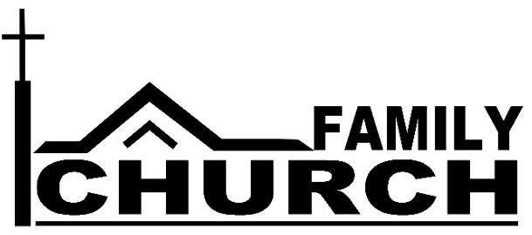
God Sets the Lonely in Families
⁴ Sing to God, sing in praise of his name,
extol him who rides on the clouds;
rejoice before him—his name is the Lord.
⁵ A father to the fatherless, a defender of widows,
is God in his holy dwelling.
⁶ God sets the lonely in families (Psalm 68:4-6).
On September 9th, we are beginning the “Family Church” series with this truth in mind: God promises to be a father to the fatherless and set the lonely in families.
What does your family look like?

This? or this? or this? or this?
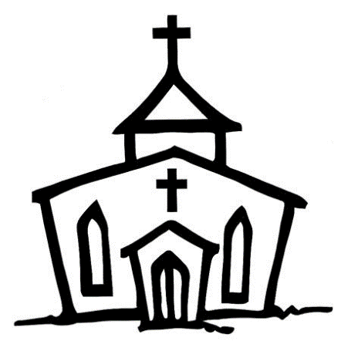

No One Alone
Our first goal in the “Family Church” effort is to make sure that everyone at St. Paul’s and The Bridge understands they are part of a family. You may be part of a nuclear family, part of a large extended family that gathers often, or you may be single, divorced, widowed or an empty nester. No matter! We are all part of the family of God.
We hope to form dozens of new Life Groups of three to a dozen people or more where individuals and couples experience that “family of God” love and care. We ask that these groups meet for Bible study and discussion for six weeks in a row to allow time for the group to coalesce. Our prayer is that these groups might become your church family where you can laugh together, pray for each other, and encourage each other. If, at the end of the six weeks, you haven’t found your group a good fit, you can discontinue meeting and try again in our next small group effort.
GroupLink – A Chance to “Try It Before You Buy It”
GroupLink (Thursday, September 13 and/or Sunday, September 16 at 6:30 pm) is a 90 minute experience to find others who are interested in becoming part of a Life Group. As you learn more about Life Groups and talk with those present, you will be able to determine those whose schedules and interests match yours so that you can form a new group.
The beauty of GroupLink is that for the last 30 minutes, you actually can have your first small group experience, getting to know each other and plan the next meeting time and location. Check GroupLink on your connection card today.

