What Time
Is It?

A Time for Action
Devotions on the Prophecy of Malachi
For November 5 – 10, 2018
Monday, November 5, 2018
Malachi 1:1-5 – You Love Him More than Me!
Did you ever feel like your mom or dad loved one of the other kids more than you?
Join the club! That’s the issue Malachi begins with. “God, you really don’t love me like you love others.” God’s people complained that God loved the descendants of Esau (the Edomites to the south of Israel) more than he loved Israel.
A prophecy: The word of the Lord to Israel through Malachi.
² “I have loved you,” says the Lord.
“But you ask, ‘How have you loved us?’
“Was not Esau Jacob’s brother?” declares the Lord. “Yet I have loved Jacob, ³ but Esau I have hated, and I have turned his hill country into a wasteland and left his inheritance to the desert jackals.”
⁴ Edom may say, “Though we have been crushed, we will rebuild the ruins.”
But this is what the Lord Almighty says: “They may build, but I will demolish. They will be called the Wicked Land, a people always under the wrath of the Lord.⁵ You will see it with your own eyes and say, ‘Great is the Lord—even beyond the borders of Israel!’ (Malachi 1:1-5)
“God, you seem to love other people more than me!” Ever had that thought in your head? They are prettier, healthier, wealthier… you name it. And sometimes they may even throw it back in your face. In their proud words or actions, it feels like they are saying, “God loves me more than he loves you.”
Ouch! It hurts!
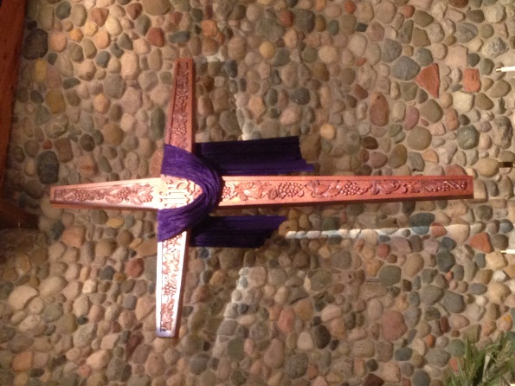
But what is the reality? “I have loved you,” says the Lord. How do you know? In New Testament times, we Christians can go back to the cross. That’s where you can be certain of God’s love. Jesus is the Lamb of God who takes away the sin of the world. That means he took your sin away. “I have loved you,” says the Lord.
Let’s confess the times we’ve challenged God: “Lord, I’ve been comparing myself to others and you seem to be treating them better than you are treating me.” Let’s recognize the same sinful attitude as Peter had when Jesus foretold Peter’s manner of death. Peter asked, “What about John?” (John 21:21) Jesus answer? “What is that to you? Follow me.”
Jesus loved Peter. Jesus loved John. He had different plans for each of them.
God certainly has different plans for you than anyone else. His plan may lead through cancer or the death of a loved one or financial hardships. But be sure of this. “I have loved you,” says the LORD.
Tuesday, November 6
Malachi 1:6-14 – Lock the Church Doors!
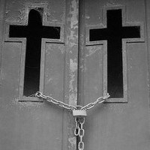
Lock the church doors!
We may see more and more of our doors securely locked as we continue to take precautions against gunmen like the one who stormed into that Pittsburgh synagogue recently.
Lock the church doors!
Imagine God saying that to us, not to keep the bad guys out, but to keep us out.
Lock the church doors!
That’s what he said to the people of Malachi’s day. “Oh, that one of you would shut the temple doors.”
⁶ “A son honors his father, and a slave his master. If I am a father, where is the honor due me? If I am a master, where is the respect due me?” says the Lord Almighty.
“It is you priests who show contempt for my name.
“But you ask, ‘How have we shown contempt for your name?’
⁷ “By offering defiled food on my altar.
“But you ask, ‘How have we defiled you?’
“By saying that the Lord’s table is contemptible. ⁸ When you offer blind animals for sacrifice, is that not wrong? When you sacrifice lame or diseased animals, is that not wrong? Try offering them to your governor! Would he be pleased with you? Would he accept you?” says the Lord Almighty.
⁹ “Now plead with God to be gracious to us. With such offerings from your hands, will he accept you?”—says the Lord Almighty.
¹⁰ “Oh, that one of you would shut the temple doors, (that is, Lock the Church Doors!) so that you would not light useless fires on my altar! I am not pleased with you,” says the Lord Almighty, “and I will accept no offering from your hands. ¹¹ My name will be great among the nations, from where the sun rises to where it sets. In every place incense and pure offerings will be brought to me, because my name will be great among the nations,” says the Lord Almighty.
¹² “But you profane it by saying, ‘The Lord’s table is defiled,’ and, ‘Its food is contemptible.’ ¹³ And you say, ‘What a burden!’ and you sniff at it contemptuously,” says the Lord Almighty.
“When you bring injured, lame or diseased animals and offer them as sacrifices, should I accept them from your hands?” says the Lord. ¹⁴ “Cursed is the cheat who has an acceptable male in his flock and vows to give it, but then sacrifices a blemished animal to the Lord. For I am a great king,” says the Lord Almighty, “and my name is to be feared among the nations” (Malachi 1:6-14).
The temple was in good repair. Offerings were being brought as Moses had commanded. Everything was great at God’s Old Testament Church. Why would God be angry?
Because they didn’t bring the best to the Lord’s altar.
But the priests just burned them up on the altar! What difference did it make if one or two of the animals were crippled? Don’t the ashes left over after burning a perfect animal and a second-rate animal look pretty much the same?
What a powerful challenge that is for us as we consider our offerings to the Lord! Sometimes you may disagree with the way the church is using your offerings.
- The congregation is too focused on outreach.
- The congregation is too focused on the school.
- The congregation is too focused on pleasing the youth.
- The congregation is too focused on pleasing the elderly.
But what if we put a Weber grill at the front of the church and just poured all our offerings on the coals? It would be pretty hard to give God our best when we knew it was just going to be burned up!
While we want to be good stewards of the offerings God entrusts to our congregation, our motivation for giving is not, “I have to be convinced they will use it wisely!”
The motivation is simply this: I want to honor God’s name because of what he has done for me. That is the primary purpose of our offerings.
Later in Malachi the Holy Spirit will give us some guidance on offerings. But for now, let’s search our own hearts. Is there a reason for God to lock the doors? Does God look at my offerings and say, “Stop bringing this meaningless offering!”
Father, you gave the very best Sacrifice, the perfect Lamb of God. You gave that Sacrifice for me, even though I have often misused that Sacrifice. This is amazing grace! Focused on that amazing grace, help me to give you the very best…
- In my offerings at church,
- In kindness to others,
- In humble service.
Use me to make known to those around me that your saving name is “great among the nations” because you have given us Jesus. In His name we pray. Amen.
Wednesday, November 7, 2018
Malachi 2:1-16 – God doesn’t want your offerings!
Imagine an offering plate with a lock on it… not to keep the offerings safe, but to keep you from giving an offering.
You might be thinking… “That will never happen!” The church needs my offerings.
The people of Malachi’s day may have thought that too. The Old Testament church at that time is much like our own. The people had come back from Babylonian exile. The temple was rebuilt. The temple was full of people. They were prosperous and giving gifts. What more could God want?
One word… faithfulness.
The people thought that if they were faithful in attending church and giving offerings, God would be pleased with them and not notice what else was happening in their lives. But God saw. And God sees today! So be on your guard!
¹⁰ Do we not all have one Father? Did not one God create us? Why do we profane the covenant of our ancestors by being unfaithful to one another?
¹¹ Judah has been unfaithful. A detestable thing has been committed in Israel and in Jerusalem: Judah has desecrated the sanctuary the Lord loves by marrying women who worship a foreign god. ¹² As for the man who does this, whoever he may be, may the Lord remove him from the tents of Jacob—even though he brings an offering to the Lord Almighty.
¹³ Another thing you do: You flood the Lord’s altar with tears. You weep and wail because he no longer looks with favor on your offerings or accepts them with pleasure from your hands. ¹⁴ You ask, “Why?” It is because the Lord is the witness between you and the wife of your youth. You have been unfaithful to her, though she is your partner, the wife of your marriage covenant.
¹⁵ Has not the one God made you? You belong to him in body and spirit. And what does the one God seek? Godly offspring. So be on your guard, and do not be unfaithful to the wife of your youth.
¹⁶ “The man who hates and divorces his wife,” says the Lord, the God of Israel, “does violence to the one he should protect,” says the Lord Almighty.
So be on your guard, and do not be unfaithful.
How foolish we are to think that our unfaithfulness has no impact on others around us! Three times Malachi asks, “Don’t we all have the same Father and Creator?” What you do impacts everyone around you!
The unfaithfulness of Malachi’s day is mirrored in our own:
- Marrying an ungodly person (or having sexual relations outside of marriage) with no thought of how this relationship will impact your relationship with your Father in heaven (marrying foreign wives in Malachi’s day).
- Unfaithfulness in marriage and divorce.
- Violence in the home.
Let us confess our own unfaithfulness:
Father, you have made me part of a large family… the family of believers. Help me remember that my actions impact the lives of my brothers and sisters in the faith around me. Help me see where I have been unfaithful… in my marriage vows or in my sexual life… or in any other area of my life. Others may not see my private sins. Even I may not see my sins clearly, but you do, Father. Therefore, I humble myself before you and claim the promise contained in your name Lord. You are the God of unchanging and faithful grace. You are the God who forgives wickedness and rebellion and sin (Exodus 34:6,7). I claim your faithfulness. I claim the faithful love of Jesus for me as the Lamb of God who has taken away my sin. Now help me to be faithful to you this day. Amen.

Thursday, November 8, 2018
Malachi 2:17–3:5 – If only God would be just!
The bullies always win! It can seem that way.
God, you aren’t fair! Why aren’t you treating the bad guys the way they deserve?
The Lord speaks to this complaint through the prophet Malachi as well.
¹⁷ You have wearied the Lord with your words.
“How have we wearied him?” you ask.
By saying, “All who do evil are good in the eyes of the Lord, and he is pleased with them” or “Where is the God of justice?”
“I will send my messenger, who will prepare the way before me. Then suddenly the Lord you are seeking will come to his temple; the messenger of the covenant, whom you desire, will come,” says the Lord Almighty.
² But who can endure the day of his coming? Who can stand when he appears? For he will be like a refiner’s fire or a launderer’s soap.³ He will sit as a refiner and purifier of silver; he will purify the Levites and refine them like gold and silver. Then the Lord will have men who will bring offerings in righteousness, ⁴ and the offerings of Judah and Jerusalem will be acceptable to the Lord, as in days gone by, as in former years.
⁵ “So I will come to put you on trial. I will be quick to testify against sorcerers, adulterers and perjurers, against those who defraud laborers of their wages, who oppress the widows and the fatherless, and deprive the foreigners among you of justice, but do not fear me,” says the Lord Almighty.
You want someone to come and be fair? Look out what you are asking for!
The “Messenger of the Covenant” about whom the Lord speaks is God himself come down in human flesh and blood. John the Baptist is the messenger who prepared the way for him. Now that Jesus has come once to take away sin, he will come back one more time for the judgment.
Who can endure his coming? Only the ones whom the Lord refines and purifies.
He refines us by passing us through the fire of God’s law that convicts us. Who are we to stand in judgment over God and claim he is unjust? We who often are unjust ourselves? The law convicts us all.
But we have also experienced the launderer’s soap. This reference takes me back to my baptism and reminds me that I have been washed in the water that promises forgiveness. It also takes me forward to the vision of the saints in heaven in Revelation 7 whose robes have been washed and made white in the blood of the Lamb.
Convicted. Forgiven. And then changed!
“The Lord will have people who bring offerings in righteousness and the offerings (of God’s people) will be acceptable to the Lord.”
Earlier this week I suggested thinking of the offering plate as having a lock on it to keep us from giving offerings as though God’s love could be bought. Here is another image. Imagine your offering in the plate covered with red Saran Wrap. That’s how God looks at your offerings. They are acceptable to him because he looks at them through the red blood of Christ.
Father, thank you for sending Jesus as the Messenger of the Covenant. If he came only as our judge, we would have reason to be afraid, for you are just and we are not. But he came to establish the New Covenant of forgiveness. You are just in punishing him in our place so that you might find us acceptable in your sight. Amazing grace! Amen.
Friday, November 9, 2018
Malachi 3:6-15 – Put God to the Test
Test me!
God doesn’t often make that statement.
When wicked King Ahaz was facing his destruction, God sent Isaiah to tell him, “Ask for a sign!” (Isaiah 7:10-14) Ahaz refused. Ahaz was sure God would fail the test. So why ask?
Test me!
Through Malachi God speaks to outwardly religious people and again says, “Test me.”
Sadly, most respond like King Ahaz. “God really can’t do this. I won’t put God to the test because I’m pretty sure he will fail.” What do you think?
⁶ “I the Lord do not change. So you, the descendants of Jacob, are not destroyed.⁷ Ever since the time of your ancestors you have turned away from my decrees and have not kept them. Return to me, and I will return to you,” says the Lord Almighty.
“But you ask, ‘How are we to return?’
⁸ “Will a mere mortal rob God? Yet you rob me.
“But you ask, ‘How are we robbing you?’
“In tithes and offerings. ⁹ You are under a curse—your whole nation—because you are robbing me. ¹⁰ Bring the whole tithe into the storehouse, that there may be food in my house. Test me in this,” says the Lord Almighty, “and see if I will not throw open the floodgates of heaven and pour out so much blessing that there will not be room enough to store it. ¹¹ I will prevent pests from devouring your crops, and the vines in your fields will not drop their fruit before it is ripe,” says the Lord Almighty. ¹² “Then all the nations will call you blessed, for yours will be a delightful land,” says the Lord Almighty.
¹³ “You have spoken arrogantly against me,” says the Lord.
“Yet you ask, ‘What have we said against you?’
¹⁴ “You have said, ‘It is futile to serve God. What do we gain by carrying out his requirements and going about like mourners before the Lord Almighty? ¹⁵ But now we call the arrogant blessed. Certainly evildoers prosper, and even when they put God to the test, they get away with it.’” (Malachi 3:6-15)
In the Old Testament, God treated his people like little children and told them exactly what to do. Like my father giving me a quarter and telling me to put it into the offering plate, so he commanded the Israelites to give the tithe (10% of their income). Would they trust him that he could provide for their needs if they gave 10% away?
In our New Testament times, God treats us as mature children. The Apostle Paul talks about this in Galatians 3:23-4:7.
The command about the tithe (giving 10% of income) no longer applies to us. We aren’t spiritual children. We have come “of age.”
But Paul also warns, “Do not use your freedom to indulge the sinful nature; rather, serve one another humbly in love” (Galatians 5:13).
In freedom, as mature children of God, let us contemplate God’s blessings and his childhood command about giving 10%. What will our proportionate response be now that we know the full extent of our God’s love in giving us his Son? Should our response be less than 10%? Should it be more? What steps can we grow to the level to which God is calling us?
Remember that God is the one who said, “Test me.”
May our offerings put God to the test! Do we trust our God that he can provide?
Let our answer be, “Yes, Lord, we believe! Help us overcome our doubts!” (Mark 9:24) Amen.

Saturday, November 10
Malachi 3:16 – 4:6 A Scroll and a Calf
When Job questioned God, God’s response was four chapters of questions (Job 38-41) to put Job in his place. Job repented in dust and ashes (Job 42:6).
At the end of the Old Testament times, when God’s people were questioning God, God again responded with questions (Malachi 1-3).
The believing response in Malachi is also repentance.
¹⁶ Then those who feared the Lord talked with each other, and the Lord listened and heard. A scroll of remembrance was written in his presence concerning those who feared the Lord and honored his name.
¹⁷ “On the day when I act,” says the Lord Almighty, “they will be my treasured possession. I will spare them, just as a father has compassion and spares his son who serves him. ¹⁸ And you will again see the distinction between the righteous and the wicked, between those who serve God and those who do not.
“Surely the day is coming; it will burn like a furnace. All the arrogant and every evildoer will be stubble, and the day that is coming will set them on fire,” says the Lord Almighty. “Not a root or a branch will be left to them. ² But for you who revere my name, the sun of righteousness will rise with healing in its rays. And you will go out and frolic like well-fed calves. ³ Then you will trample on the wicked; they will be ashes under the soles of your feet on the day when I act,” says the Lord Almighty.
⁴ “Remember the law of my servant Moses, the decrees and laws I gave him at Horeb for all Israel.
⁵ “See, I will send the prophet Elijah to you before that great and dreadful day of the Lord comes. ⁶ He will turn the hearts of the parents to their children, and the hearts of the children to their parents; or else I will come and strike the land with total destruction.” (Malachi 3:16 – 4:6).

In this study of Malachi, I have been amazed at how offerings come up over and over. Malachi served in a materialistic culture. God used him to ask point blank.
- “Do you revere My name?”
- Will you honor Me in your financial decisions?
Our materialistic culture impacts us as well. That culture impacts us so that what would have been a luxury just a decade ago becomes a necessity. God speaks to us through Malachi and asks us:
- “Do you revere My name?”
- Will you honor Me in your financial decisions?
In humility, let us join the believers of Malachi’s day. Let us write “a scroll of remembrance.” Let us commit ourselves to prayerfully asking, “Lord, what does it look like to honor you in all my financial decisions? Lord, what does a generous offering look like for me? What percentage? What steps can I take to grow toward a percentage that gives you the honor your saving name deserves?”
And then let us rejoice… for as we revere God’s name… standing in awe of God’s amazing grace in Christ… honoring him in our lives… we can look forward to leaping like calves from the stall.
“But for you who revere my name, the Sun of Righteousness will rise with healing in its rays. And you will go out and frolic like well-fed calves” (Malachi 4:2).
If you have never seen it, google “calves leaping” and find this 14 second video. I can’t wait to feel the warmth of God’s Son shining down on us on the first day of eternity. I can’t wait to feel that healing. I can’t wait to see you jump like a calf with me. Amen.

The Giving Ladder
I began these devotions for myself because I realized for the first time that the entire prophecy of Malachi was about offerings.
Will God accept my offerings?
Surprisingly, the answer throughout most of the prophecy is, “No!”
Acceptable offerings can only come from “those who revere my name.” It is only through repentance for our sins and faith in the Savior that we and our offerings are acceptable to God.
Now, as God’s forgiven children, God invites us to test him.
But what does that mean? It likely means something different for every person, depending on where they are on the “giving ladder.”
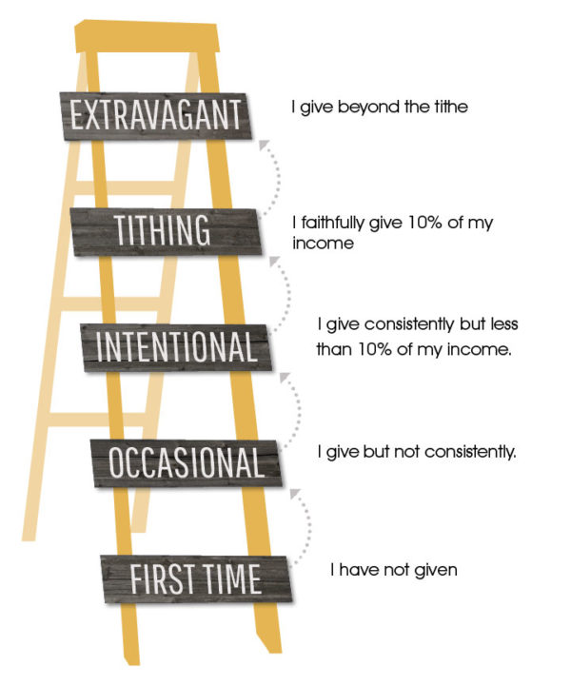
First time: If you really don’t have a plan to give, perhaps the place to start is Financial Peace University, a financial planning course that will be offered in January, 2019.
Occasional: Perhaps the next step is to use online giving to make your giving consistent. Go to www.stpaulmuskego.org/give. You can sign up for your gifts to be given weekly or monthly. The most cost-effective way for St. Paul’s to receive your gift is by giving directly from a checking or savings account. However, you can give using a credit card as well.
Intentional: You give consistently, but perhaps you don’t know what percentage you are giving to the Lord. Divide your yearly offering by your yearly income. What percentage are you giving at now? What percentage do you feel would honor God? Increase the percentage gradually, year-by-year, to attain the goal that you feel God is calling you to.
Tithing: If you are already giving 10% of your income, consider if that is the proportionate response to what God has given you and the ministry opportunities that lie before you. Perhaps this is a time in life when God is enabling you to do more.
Extravagant: One area of giving that is often overlooked is the opportunity to give through your accumulated assets. Have you made plans to give generously through your estate plans? If you would like to know more about St. Paul’s Gift Trust Fund and Legacy Fund that have been set up especially for large gifts and estate gifts, speak to Pastor Panitzke (414-350-1436).

